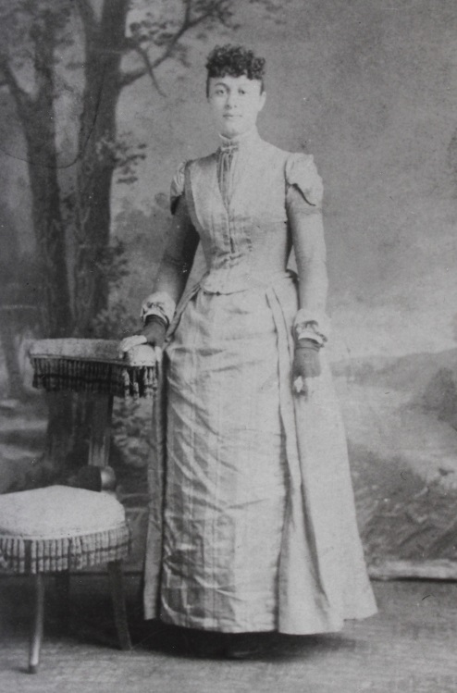

Margaret (Maggie) Kern List, mother of

Luther J. List – about 1900 (est.)

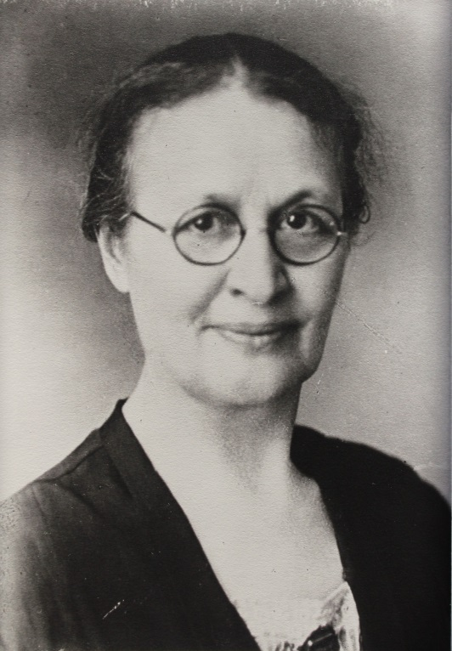

Margaret Kerns List – about 1930 (est.)